**Reference No:** C25…..

**Damage Report Date:** .15/10/13...

**Incidents must be reported immediately.**

Damage found in Container must not to be touched until pictures have been taken to effectively demonstrate to stake holders how damage could have occurred?

In Container Container No. CBHU8732118

In Warehouse How was it damaged? Products too heavy.

Product

KHKSK277 X5

*Insert* Picture:

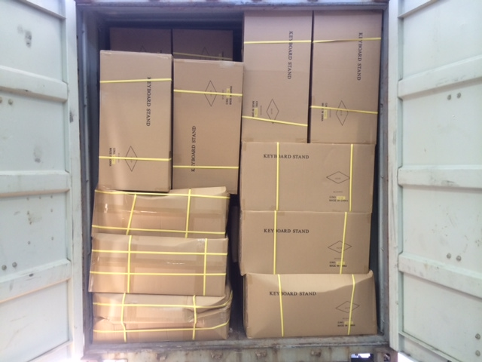

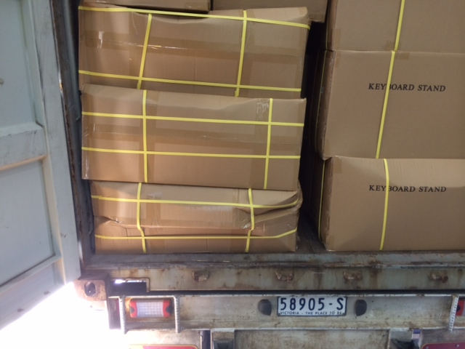

Reported by…Frank V…………………………………….